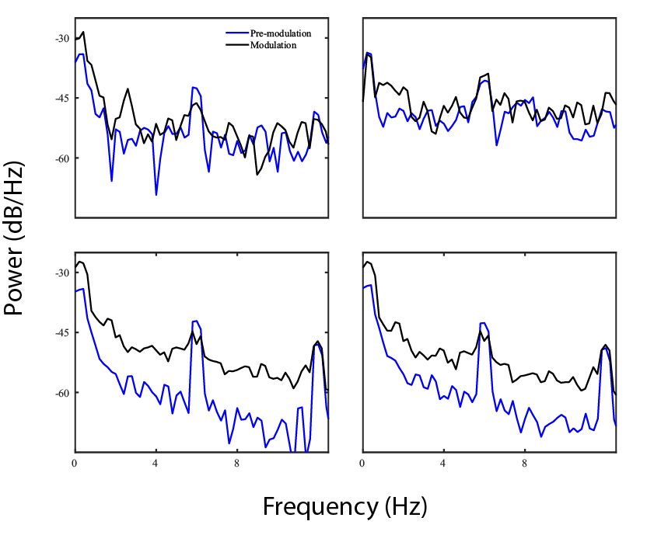

Figure S1. PSD for 5 s periods before (blue) and after (black) closed-loop desynchronization for 4 ROIs. The amplitudes of the individual regions remain the same or decrease slightly with modulation, but the signal-to-noise ratio decreases significantly, indicating that stimulation adds power to the frequencies close to the oscillation frequency.

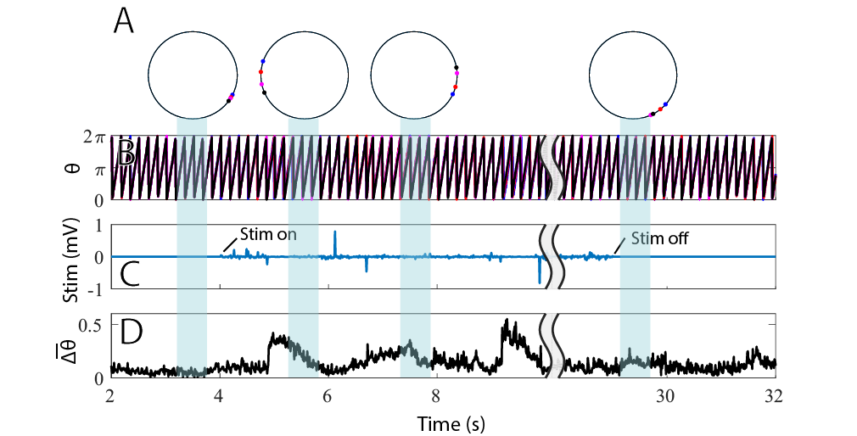

Figure S3. Feedback-controlled desynchronization in neurons. A) Average phases of the 4 ROIs at selected times plotted on the unit circle. B) Phase of each of the 4 ROIs over time. C) Stimulation waveform in mV. The feedback controller is turned on at 5 s. D) Average phase difference between the 4 clusters. Phases diverge within a few seconds after the stimulus is turned on. The ROIs stay partially desynchronized after the feedback controller is turned off.

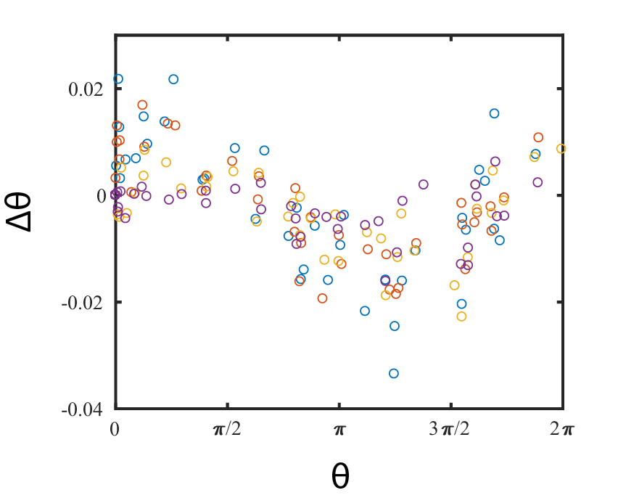

Figure S2. Estimating the PRC of the calcium oscillation responses to electrical stimulation. Four colors represent phase advances measured over four ROIs.